QUEENS CROSS HOUSING ASSOCIATION  EXECUTIVE MANAGEMENT TEAM MEETING |  | Date  FOR Approval/discussion  ITEM NO. X.X
RTF Recommendations Report – Close Cleaning
Executive Lead | Neil Manley
Lead Officer/Author | Katie Blair
Action Required | To approve recommendations made.
Key Points | The RTF have made recommendations on the close cleaning service provided. These are based on complaints made about close cleaning and inspections of closes.
Timing | For RTF meeting on Thursday 3 March 2022.
Financial Implications | None
Engagement | Engagement with Housing and Maintenance Teams.
Equality, Diversity, Inclusion | EDI has been considered and no issues identified.
Risk | No risks identified.
Contribution to QCHA strategy | Build and maintain popular neighbourhoods  Develop Greener spaces and community wellbeing

Note: One page cover sheet

1. | RECOMMENDATION
1.1 | The RTF have made recommendations based on:  Cleaning products/Health and safety  Time allocated for cleaning  Checks on standard of cleaning  Maintenance of closes  Value for Money.
1.2 | The report does not need to be made public.
2. | BACKGROUND
2.1 | The RTF made the decision to scrutinise the close cleaning service asking if the service is value for money. The group started by looking at complaints made from customers about the standard of cleaning in their close and inspected 14 closes in October and November.
3. | PROPOSAL
3.1 | Cleaning products and health and safety  - The group raised concerns about flammable or harmful chemicals being used to clean closes.  - Products used are leaving marks on the stairs where water is spilling on to the side of the stairs (see photo in Appendix 1).  - The RTF noted that in some closes, dirt and dust was being swept into the window area (see photos in Appendix 2) and concerns were raised that a build up of dirt and dust could be a fire hazard.  - The RTF recommend that the Association find out what is used to clean the closes and that the Association ensure that products used are not a risk to health and safety and do not leave marks on the stairs. The RTF recommend that dirt and dust as swept and removed from the close and not swept in to one area such as the windows.  Time allocated to each close  - The RTF found that for the majority of closes, items on the close cleaning checklist were not being completed.  - The RTF recommend that the time for each close to be cleaned is agreed with contractors and that adequate time is allocated for workers to complete each task on the checklist. The amount of time should take into consideration the number of workers allocated to clean each close. The expectations put on workers to clean each close should be realistic and the association should make sure that expectations are not excessive.  - It was evident from inspections that some items such as light fittings hadn’t been cleaned in some time. The RTF noted that some items on the checklist do not need to be cleaned every week. The RTF recommend that consideration is given to how often each item on the check list realistically needs to be cleaned. Where items need cleaned less often, the RTF would recommend agreeing a new target for these items and updating the checklist. It is more likely that they will be cleaned regularly if the target set is realistic.  Checks on standard of close cleaning  - The RTF recommend that Housing Officers and Contractors have a regular program of inspections for closes. This should include inspecting closes where complaints have been made.  - Contractors should look for any practical problems that workers cleaning the close face such as with parking issues.  Maintenance of closes  - Some closes were not well maintained with paint coming off walls or stains on the floor. This makes is difficult for cleaning to be carried out properly.  - The RTF recommend working with contractors to understand where problems with close cleaning are due to maintenance of the close and resolving these issues.  Value for money  - The RTF were not able to find out how much close cleaning services cost during their investigation. The RTF recommend that the Association make information available to residents on how much of their rent or service charge pays for close cleaning services.
3.2 | The RTF decided to work on this scrutiny topic as they want to improve the service for tenants and owners and ensure customers are getting value for money.
3.3 | The RTF looked at the close cleaning complaints made from July 2019 to July 2021 and chose to inspect closes where complaints had been made about the standard of cleaning. There were 23 complaints made during this time. Inspections were carried out in October and November 2021. The RTF used the Close Cleaning Checklist which details what should be cleaned at each clean to assess what had and had not been done. The RTF found their research was limited as they were not provided with information on how much it costs to clean each type of close (tenement, high rises etc). The group found that they are were not able to fully decide if the close cleaning service is value for money without this information but have made recommendations on the overall standard of the service.
3.4 | The proposal fits in with the following strategic aims:  - Build and maintain popular neighbourhoods  - Develop Greener spaces and community wellbeing
3.5 | The proposal also fits in with the Nurture your Neighbourhoods campaign.
4. | TIMING
4.1
Action | Date
Approve recommendations | 3 March 2022 – RTF meeting date

5. | RESOURCE & MONITORING
5.1 | Input will be required from the Maintenance team to work with close cleaning contractors to meet recommendations This will include:  - finding out what products are used to clean closes,  - getting more information about the amount of time allocated to clean each close,  - ensuring closes are maintained properly.  Input from the Housing Team and Maintenance team will be required to ensure adequate checks of closes are being carried out by Housing Officers and contractors.
5.2 | The project is led by the RTF and Performance and Customer Engagement Officer. Recommendations will be implemented by maintenance and housing teams.
5.3 | The RTF will revisit this topic to assess how changes have impacted the service. This will be scheduled into the RTF’s plan for scrutiny activity in 2022.
6. | FINANCIAL IMPLICATIONS
6.1 | There are no additional costs involved. The work the RTF have recommended is already within the remit of Housing and Maintenance Teams.
7. | ENGAGEMENT
7.1 | Improvements to the close cleaning service will benefit all service users equally.
7.2 | The Performance and Service Improvement Officer has been involved in providing information about complaints. The Maintenance Team have provided information on close cleaning including the schedule for close cleans and the checklist for cleaning. Joanna Peters, Housing Officer provided support with inspecting closes. The RTF will monitor the progress by revisiting the project in 2022.
8. | EQUALITY, DIVERSITY, INCLUSION
8.1 | The RTF represent all service users and part of their objective is to scrutinise from the perspective of all service users from across the nine protected characteristics, rather than just from their own perspective.
8.2 | No inconsistencies between protected characteristics have been identified.
9. | RISK ASSESSMENT
9.1 | There are no risks involved.

Appendix 1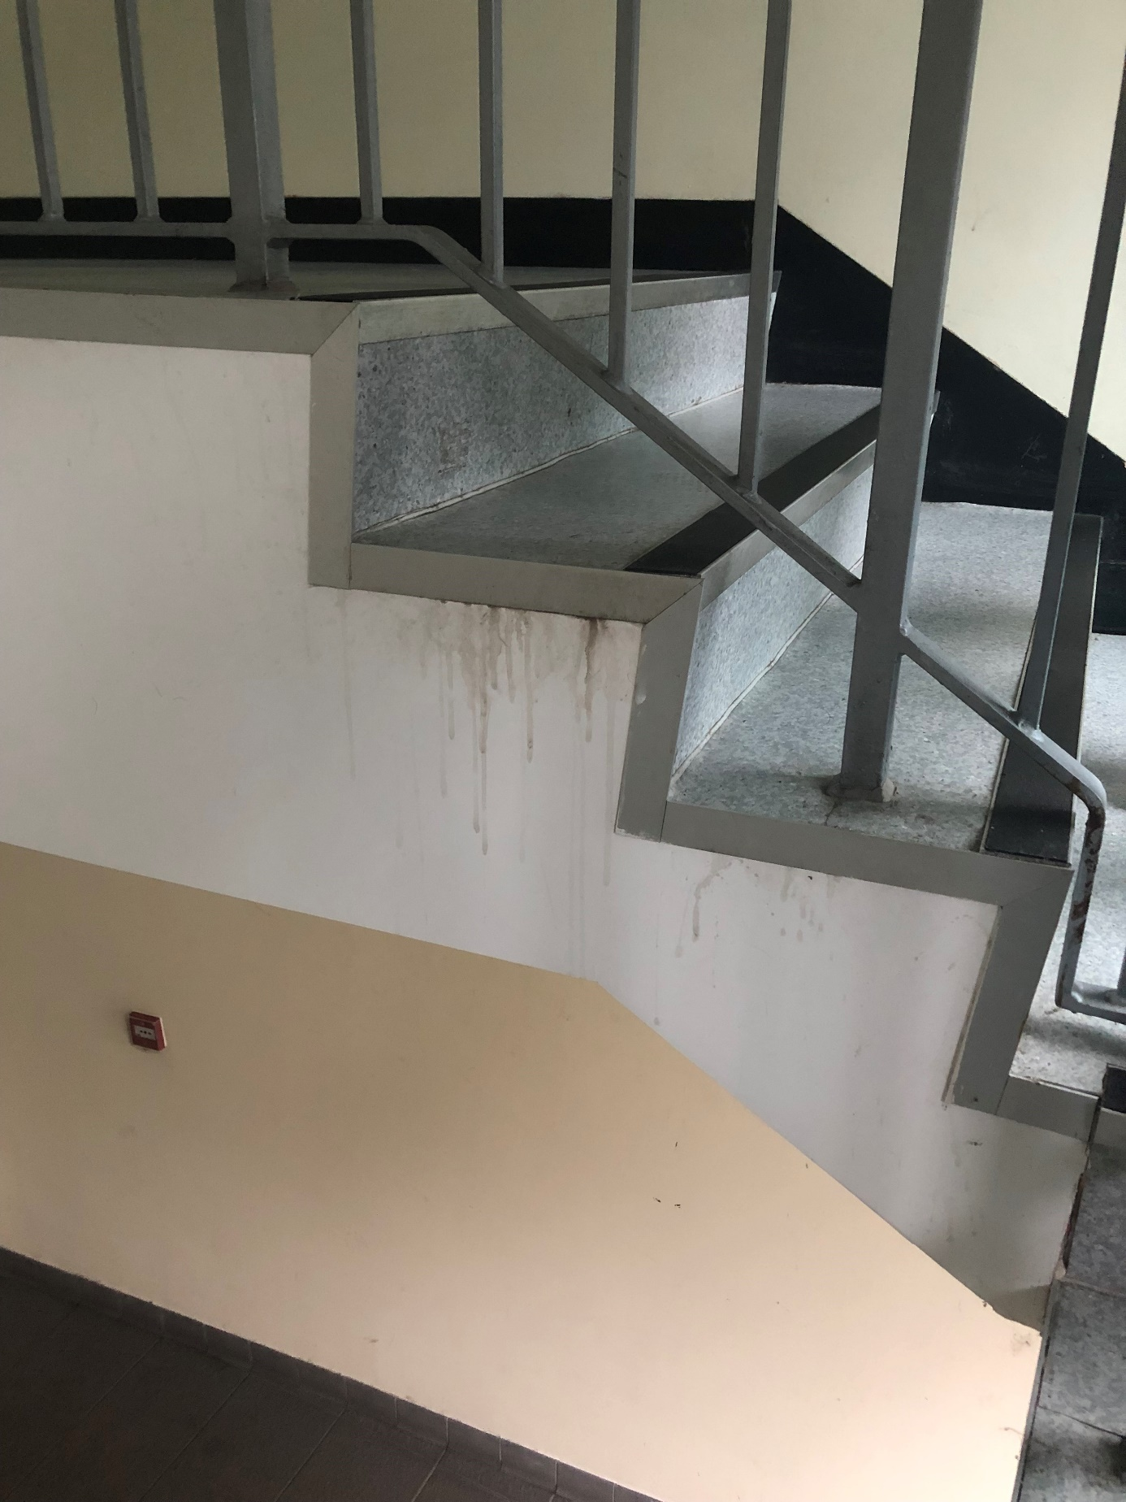

Appendix 2

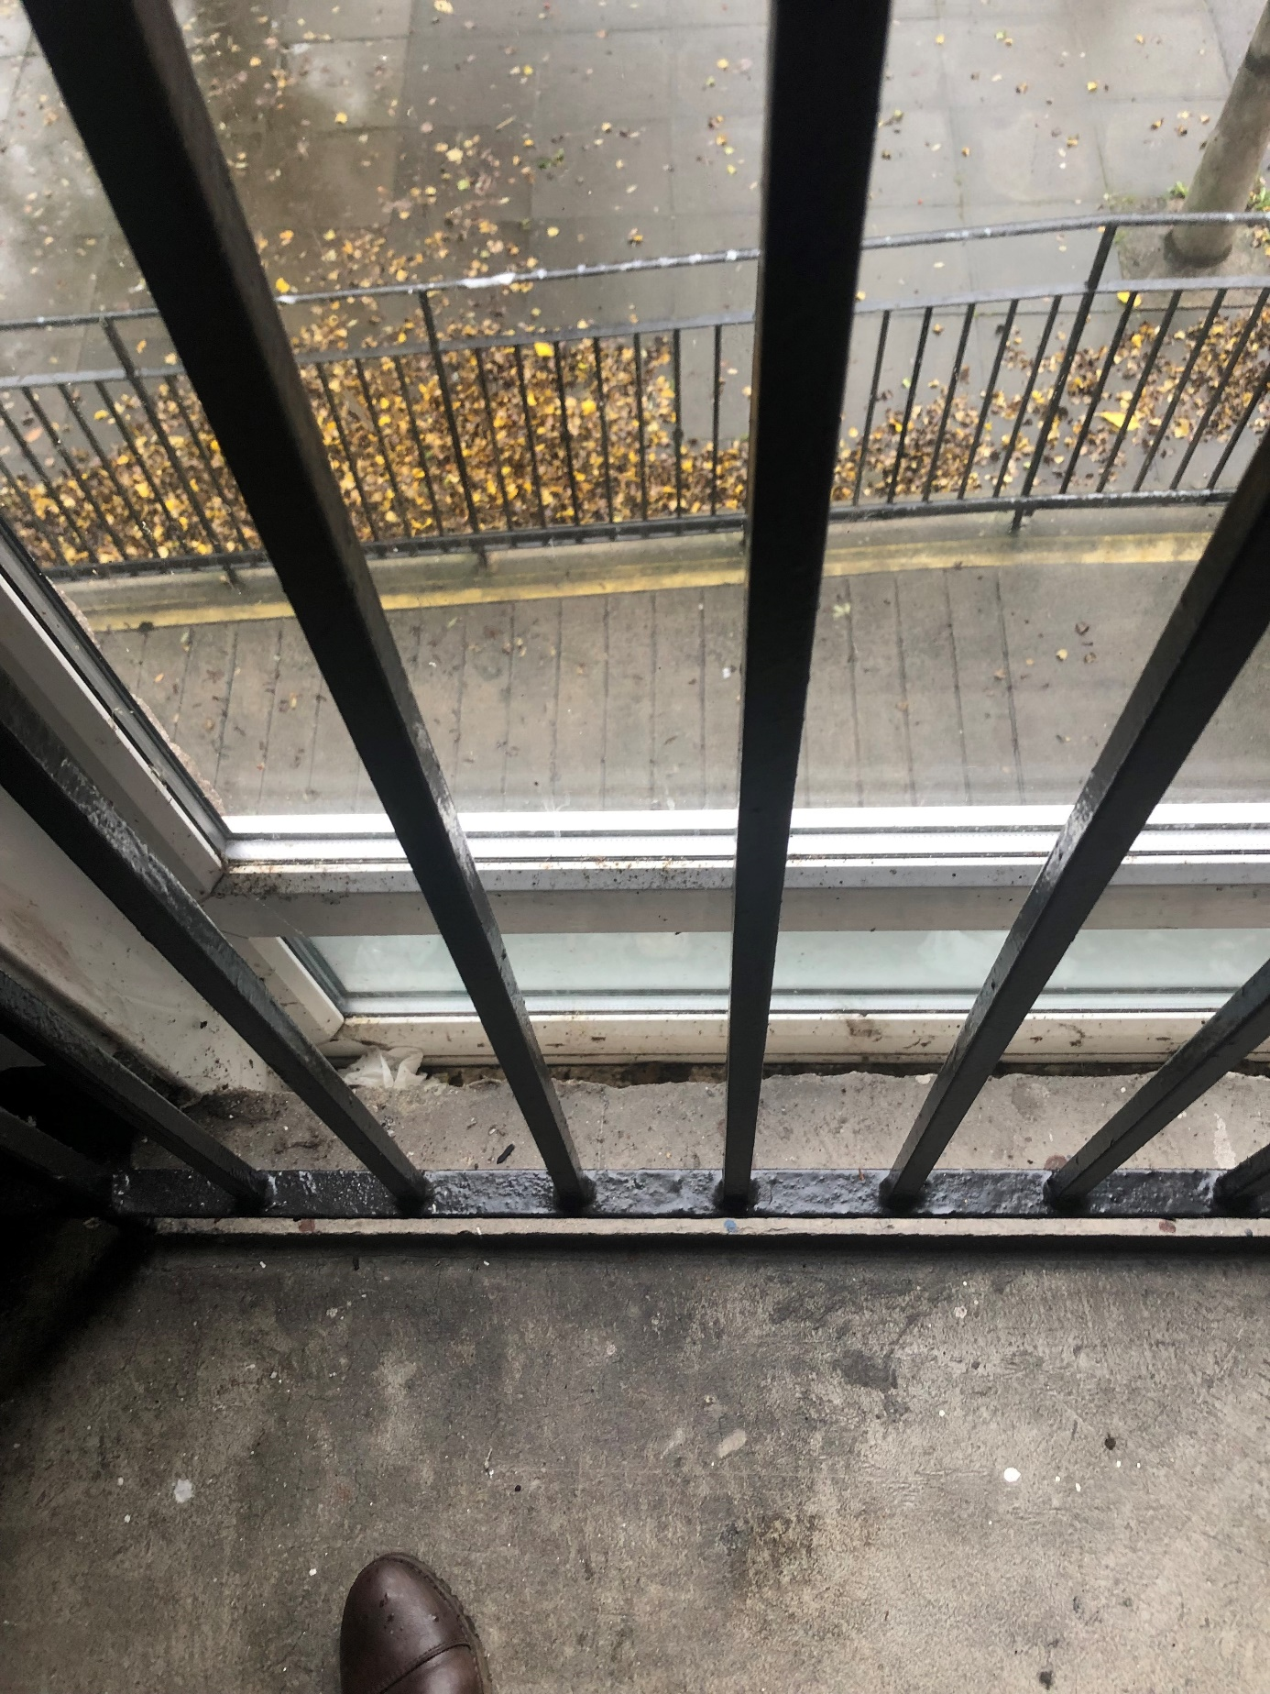

Appendix 3
Checklist Item | Total number of closes where item was not complete
Brush and wash stairs/landings or hoover carpets | 11  78.5%
Damp wipe any close tiles | 7  50%
Clean all window ledges | 7  50%
Dust and wipe down all handrails & skirtings | 6  43%
Wipe down front and rear close doors | 6  43%
Sweep front and rear close entrances and steps | 1  7%
Sweep lift floors and clean lift car interior & exterior architraves | 1  7%
Remove litter from close entrance | 2  14%
Clean and polish any door brasses on entrance door | 2  14%
Wipe down door entry panels and close door windows | 8  57%
Remove cobwebs from walls and ceilings | 6  43%
Remove all debris from site including junk mail/flyers left on floors/window ledges | 3  21%
Damp wipe all metal balustrades | 3  21%
Clean and polish close tiles | 3  21%
Clean all internal common window glass | 7  50%
Dust and wipe down all light fittings | 7  50%
Is the equipment being used clean and adequate to carry out workload? | Unclear
Are the walls being cleaned regularly and free from graffiti? | 7  50%
Is it fresh, clean water being used when carrying out cleaning? | 2  14% - unclear as we have not seen the water
Are the relevant safety signs being displayed if required? | Unclear – not attending during clean
Are there puddles/damp patches left following the clean? | 0  0%
Are there differences in the standards of cleanliness on each floor? | 6  43%
Is the workers checklist being ticked off without carrying out the full workload? | 1  7%

