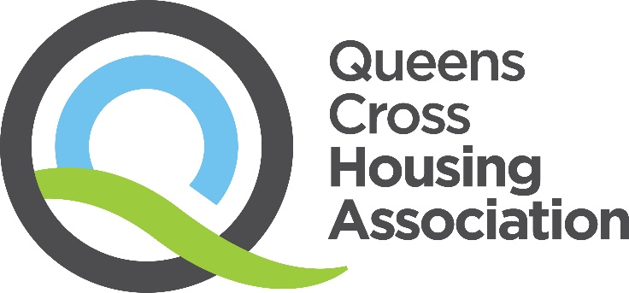

Child Protection Policy
(October 2024)

Consultation completed: | July 2024
Approved: | November 2024
Review Date: | October 2027

Our Vision, Values & Strategic Objectives

Our Vision
Excellent housing in vibrant communities.

Our Values

Respect
We see the positive in everyone, especially our tenants. We treat everyone fairly, regardless of age, race, gender, sexuality or background. We ask for opinions even if we know we might not like what we hear. And we address people’s concerns in any way we realistically can.
Integrity
What we say in public is the same as what we say behind the scenes. If we say we’ll do something, we mean it. Our tenants can count on us to solve their problems and make sound decisions.
Aspiration
We want the best for all our current and future tenants. We’re not afraid to strive for things that won’t be easy – or try things that haven’t been done before. We seek out opportunities and welcome change. If it doesn’t turn out as planned, we learn and improve again. And then we try again.

Our Strategic Objectives

- Building and sustaining popular neighbourhoods
- Creating and supporting greater life opportunities for all
- Developing greener spaces and community wellbeing
- Being a dynamic and listening community partner
- Treating people equally and with respect

Contents

1 | Introduction | Page 3
2 | Scope | Page 3
3 | Definition of Safeguarding | Page 4
4 | Definition of Child Abuse | Page 4
5 | Child Sexual Exploitation (CSE) | Page 5
6 | Named Person | Page 7
7 | Confidentiality and Sharing Information | Page 7
8 | Other | Page 7
9 | Monitoring and Review | Page 8
10 | Related Policies and Documents | Page 8

1. Introduction
1.1 Queens Cross Housing Association Ltd (QCHA) is committed to the protection of children and young people and regards the safeguarding and wellbeing of children and young people as of paramount importance. QCHA consider it the duty of all those employed or involved with the organisation to prevent the physical, sexual or emotional abuse of all children and young people with whom they come into contact with. This includes reporting any abuse discovered or suspected.

1.2 QCHA commitment to child protection principles including:-

- Protection of a child or young person at risk of harm is the responsibility of all agencies. The expectation that all “at risk” children and young people in our communities are kept safe through support from all public services including social work services, police, health, housing and care.
- Safeguarding and promoting the wellbeing of a child of a young person who is at risk. In circumstances where we find that a child or young person is at risk we will liaise with Glasgow City Council Health and Social Care Partnership and / or Police. See Child Protection Procedure for more information.
- Recognition that the protection of a child or young person at risk of harm is placed above all other operating procedures and supersedes the principle of confidentiality.

  - QCHA recognise that:-

- Children and young people have the right to be protected from all forms of abuse, neglect and exploitation.
- The welfare of the child or young person is paramount.
- No child or group of children or young people must be treated less favourably than others in being able to access services which meet their particular needs.
- All children and young people regardless of age, disability, gender, racial heritage, religious belief, sexual orientation or identity have a right to equal protection from all types of harm or abuse.
- Some children and young people are additionally vulnerable because of the impact of previous experiences, their level of dependency, communication needs or other issues.
- Working in partnership with children, young people, their parents, carer’s and other agencies is essential in promoting children and young people’s welfare.
- Children and young people should be listened to and their views taken into account in decisions affecting them.

2. Scope
2.1 This Policy applies to all the Association’s Governing body members, employees, volunteers and anyone delivering a service on behalf of QCHA.

3 Definition of Safeguaring
3.1 Safeguarding is a term which is broader than ‘child protection’ and relates to the action taken to promote the welfare of children and young people, including protecting them from harm. Safeguarding is everyone’s responsibility.
Safeguarding children and young people means:-
- Protecting children and young people from maltreatment.
- Preventing impairment of children and young people’s health and development.
- Ensuring that children and young people grow up in circumstances consistent with the provision of safe and effective care, and taking action to enable all children and young people to have the best outcomes.

3.2 QCHA will safeguard children and young people through:-

- Valuing them, listening to and respecting them.
- Adopting child protection and safeguarding practices.
- Providing effective management for staff and volunteers through supervision, support, training and quality assurance measures.
- Recruiting staff and volunteers safely ensuring all necessary checks are made.
- Using our procedures to share concerns and relevant information with agencies, who need to know, and involving children, young people, parents, families and carers appropriately.
- Ensuring that we have effective complaints and whistleblowing measures in place.
- Ensuring that we provide a safe physical environment for our children, young people, staff and volunteers by applying health and safety measures in accordance with the law and regulatory guidance.

4. Definition of Child Abuse
4.1 This policy relates to safeguarding of children and young people. A 'child' is defined as a child or young person up to 18 years of age in line with the United Nations Convention on the Rights of the Child. The safeguarding of children and young people also includes unborn babies.

4.2 The definition of child abuse is "Abuse and neglect are forms of maltreatment. Abuse or neglect may involve inflicting harm or failing to act to prevent harm. Children may be maltreated at home; within a family or peer network; in care placements; institutions or community settings; and in the online and digital environment. Those responsible may be previously unknown or familiar, or in positions of trust. They may be family members. Children may be harmed pre-birth, for instance by domestic abuse of a mother or through parental alcohol and drug use” (National Guidance for Child Protection in Scotland 2021).

  - The types of child abuse are:-

- Physical Abuse (causing physical harm)
- Emotional Abuse (persistent emotional ill treatment that has severe and persistent adverse effects on emotional development)
- Sexual Abuse (including Child Sexual Exploitation (CSE))
- Criminal Exploitation (actions of an individual or group using an imbalance of power to coerce, control, manipulate or deceive into criminal activity)
- Child Trafficking (recruitment, transportation, transfer, harbouring or receipt, exchange or transfer of control of a child for the purpose of exploitation)
- Neglect (persistent failure to meet a child’s basic physical and/or psychological needs, which is likely to result in the serious impairment of the child’s health or development)
- Female Genital Mutilation (FGM)
- Forced Marriage (a marriage conducted without the full and free consent of both parties and where duress is a factor if under 18)

4.4 Children and young people rarely tell you that they are being abused. However there may be signs which indicate a child or young person is being abused or neglected These include:-

- Unexplained bruising
- Appear afraid, quiet or withdrawn
- Being afraid to go home
- Appear hungry, tired or unkempt
- Left unattended or unsupervised
- Having too much responsibility for their age
- Acting in a sexually inappropriate way

Not all children and young people who are being harmed will display these signs. You may have other reasons to be worried about a child or young person e.g. when a responsible adult is acting in a violent manner towards a child or misusing drugs or alcohol while caring for a child.

5. Child Sexual Exploitation (CSE)
5.1 CSE occurs where an individual or group takes advantage of an imbalance of power to coerce, manipulate or deceive a person under 18 into sexual activity in exchange for something the victim needs or wants, and/or the financial advantage of increase status of the perpetrator or facilitator. The victim may have been sexually exploited even if the sexual activity appears consensual. CSE does not always involve physical contact. It can also occur through the use of technology.

5.2 CSE can be difficult to identify as many children, young people and professionals can misinterpret such experiences as consensual and fail to recognise the exploitation involved. Victims of CSE may also not recognise that they have been exploited. Disclosure of sexual exploitation can be particularly difficult for young people; the sophisticated grooming and priming processes conducted by perpetrators and the exchange element of this form of abuse can act as an additional barrier to disclosure. However as with other forms of child abuse, the presence of perceived consent does not undermine the abusive nature of the act.
  - CSE can and does, affect children from all walks of life, with no obvious pre-identified
vulnerabilities. However there are particular experiences that can heighten vulnerability including:-
- A history of abuse, neglect and / or disadvantage
- Being looked after, or formerly looked after
- Disrupted family life, including family breakdown, domestic violence and/or problematic parenting
- Disengagement from education and isolation from other support mechanisms
- Going missing from home or care environments
- Drug or alcohol misuse
- Poverty or homelessness
- Poor health and wellbeing, social isolation, bullying or low self-esteem
- Having a disability

  - Potential indicators of CSE are:-

- Acquisition of money, clothes, mobile phones etc. without plausible explanation
- Drugs / Alcohol misuse
- Isolation from peers / social networks
- Exclusion or unexplained absences from school, college or work
- Persistently going missing or returning late
- Returning distraught / dishevelled
- Unplanned pregnancy
- Inappropriate sexualised behaviours
- Physical symptoms of infection e.g. bruising, bite marks
- Relationships with controlling individuals
- Concerning use of the internet
- Increasing secretiveness around behaviours

  - Any concerns that CSE is taking place should be reported in a similar way to other child protection concerns. This includes circumstances where there is a lack of evidence or where concerns cannot be substantiated. It is also important that we do not wait for disclosure from a young person before making a referral.

6. Named Person
6.1 QCHA acknowledges that having a specific member of staff as a named person in respect of child protection is good practice. This person will have the knowledge and expertise to deal with child protection concerns. This person will ensure there is a consistent response to child protection concerns and will have an overview of child protection concerns raised.
6.2 The named person is:- Sharon Freeman (Wellbeing for Young People). If this person is unavailable Alana Stewart (Family Wellbeing Project Manager) will stand in.

7. Confidentiality and Sharing Information
7.1 If a child or young person’s wellbeing is considered to be at risk relevant information must be shared with police and / or social work. Child protection concerns will supersede the principles of confidentiality within the organisation. The organisation will notify parents, persons with parental responsibility and children / young people that this policy exists.
7.2 At all times information shared should be relevant, necessary and proportionate to the circumstances of the child, and limited to those who need to know. Information will be shared securely and there will be records of what information has been shared and why.

8. Other
8.1 QCHA complies with the Protection of Vulnerable groups (PVG) scheme in recruiting all staff and volunteers involved in supporting children and young people.
8.2 All QCHA staff and volunteers who are in contact with children and young people will be fully inducted and trained in child protection to ensure they are competent and confident in carrying out their responsibilities for safeguarding children and young people. This includes how to recognise signs that a child or young person may be at risk and how to report this. Staff who work regularly with vulnerable children and their families, will receive in-depth training.
8.3 Staff have appropriate supervision and support, and opportunities for reflective practice when they are involved in safeguarding of children and young people.
8.4 The Wellbeing teams that are registered as support providers have a specific duty of candour, as defined in the Health (Tobacco, Nicotine etc. and Care) (Scotland) Act. When an incident invokes this Act this should be reported to the Associations named responsible person for the service area of the organisation who will then complete the duty of candour process.

9. Monitoring and Review
9.1 This Policy will be subject to a review every three years, or sooner in the event of any relevant legislative or regulatory changes or best practice guidance.

10. Related Policies and Documents

QCHA Child Protection Procedure

QCHA Adult Protection Policy

QCHA Recruitment Policy

QCHA Whistleblowing

QCHA Code of Conduct

Footnotes and references

National Guidance for Child Protection in Scotland 2021

Children and Young People (Scotland) Act 2014

United Convention of the Rights of the Child
Contact Us

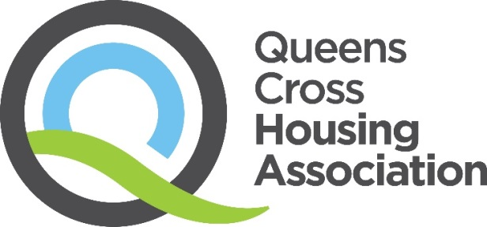

45 Firhill Road, Glasgow, G20 7BE
Telephone
0808 143 2002

Email
contactus@qcha.org.uk

Visit
www.qcha.org.uk

Need another version of this document?

We can provide this document in different formats. If you would like a copy of this document in another language, in large print, in Easy Read, on audio tape, on video in British Sign Language (BSL), on CD or in Braille, please ask us:
Telephone: 0808 143 2002
Email: contactus@qcha.org.uk
You can also download this document from our website at www.qcha.org.uk
