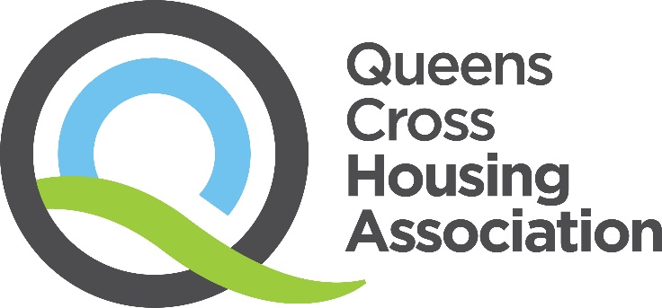

Child Protection Procedure
(October 2024)

Consultation completed: | July 2024
Approved: | November 2024
Review Date: | October 2027

Our Vision, Values & Strategic Objectives

Our Vision
Excellent housing in vibrant communities.

Our Values

Respect
We see the positive in everyone, especially our tenants. We treat everyone fairly, regardless of age, race, gender, sexuality or background. We ask for opinions even if we know we might not like what we hear. And we address people’s concerns in any way we realistically can.
Integrity
What we say in public is the same as what we say behind the scenes. If we say we’ll do something, we mean it. Our tenants can count on us to solve their problems and make sound decisions.
Aspiration
We want the best for all our current and future tenants. We’re not afraid to strive for things that won’t be easy – or try things that haven’t been done before. We seek out opportunities and welcome change. If it doesn’t turn out as planned, we learn and improve again. And then we try again.

Our Strategic Objectives

- Building and sustaining popular neighbourhoods
- Creating and supporting greater life opportunities for all
- Developing greener spaces and community wellbeing
- Being a dynamic and listening community partner
- Treating people equally and with respect

Contents

1 | Introduction | Page 3
2 | Responsibilities of QCHA Staff | Page 3
3 | Circumstances where you have concerns about a child or young person | Page 3
4 | What to do if you think a child or young person is at risk? | Page 3
5 | What happens next? | Page 4
6 | Supporting the child or young person through the child protection referrals | Page 5
7 | Related Policies and Documents | Page 5

1. Introduction
1.1 This procedure details what you should do if you are concerned about the wellbeing of a child or young person.
1.2 This should be read in conjunction with the Associations Child Protection Policy.

2. Responsibilities of QCHA Staff
2.1 Any concerns or reports that a child or young person may be at risk of harm including anonymous contact should be taken seriously. In all instances the information must be reported immediately to your line manager or the Child Protection leads in the Association.
2.2 In the event that you become aware that a child or young person may be at risk of harm or you are told directly by a child or young person that they are being / have been abused these should be reported following the guidance in this procedure.
2.3 Don’t assume that someone else has reported this.

3 Circumstances where you have concerns about a child or young person
3.1 A child or young person has disclosed to you that they have suffered harm or are at risk of harm. This includes historical abuse. You should listen with care, but do not ask any unnecessary questions.
3.2 You have witnessed certain behaviours by a child or a young person, or certain behaviours from others in their lives towards them.
3.3 You have concerns about the environment that the child or young person is living in.

4. What to do if you think a child or young person is at risk?
4.1 If you think that the child or young person is in immediate danger you should not delay and contact emergency services – 999.

4.2 If you have concerns about a child or young person that does not amount to risk of significant harm but gives you cause for concern you should contact other agencies who have contact with the child e.g. social worker, Health Visitor, Child Protection Lead at school.

4.3. If you have concerns about a child or young person is at risk of significant harm but not immediate harm you should phone:-
- Health and Social Care Connect 0141 287 0555 (during office hours)
- Glasgow and Partners Emergency Social Work Services 0300 343 1505 (out with office hours).

4.4 When making a Child Protection referral it is useful to have the following information:-
- your name, contact details and agency and your involvement with the family.
- the child's full name, age, date of birth and address. The child's current whereabouts and who they are with and what you are concerned about.
- the name, age and address of the child's parents/carers and/or any other adults who have care of the child. Who it is thought may have harmed the child or may pose a risk to them, and where and what may have happened.
- is the child in imminent danger.
- any other children who may also be at risk.
- the name, age and address of any other person known to have information on the alleged or suspected abuse.
- whether there are any other agencies currently involved with the family e.g. health visitor, teacher, school nurse or any other health professional involved with the family.
- whether there have been any previous concerns about this child or other children in the household.
- whether the child has any disabilities or special needs (if so further information regarding the child's diagnosis if any, the main difficulties affecting functioning, any medical conditions, how the child communicates and expresses emotions should be provided).
- whether there are any cultural or religious factors which need to be taken into account.
- whether the parents are aware of the concerns.

It does not matter if you don’t have all the information above, do not delay in sharing concern.
4.5 Any concerns you have about a child or young person should be brought to the attention of the Association’s Child Protection lead. They will have the skills and knowledge to offer you advice and support. They will also update the Association’s
Child Protection referral register and conduct regular reviews of practice related to Child Protection referrals.

4.6 All concerns relating to children and young people should be recorded e.g. QL, Wellbeing app.

5. What happens next?
5.1 It is the duty of Social Work Services to investigate matters of concerns in relation to the protection of children and young people. Where an alleged crime has taken place, this will be a joint investigation with Social Work Services and Police.
5.2 The investigating Social Worker / Police Officer will require to speak to staff that have been involved with the child protection referral. You should co-operate fully with any future enquiries.
5.3 If you are unhappy with the response to the child protection referral discuss this with the Associations Child Protection Lead about next course of action.

6. Supporting the child or young person through the child protection referrals
6.1 It is important that during the child protection policy that you continue to act in a supportive manner to child or young person and take a welfare based approach. You should:-

- Continue to listen with care.
- Reassure the child or young person he/she was right to tell, if appropriate.
- Affirm the child or young person’s feelings as expressed by them.
- Do not question/interrogate the child or young person.
- Do not show disbelief.
- Avoid being judgmental.
- Do not introduce personal or third party experiences of abuse.
- Avoid displaying strong emotions.

6.2 Liaise with social work and police for updates during the child protection referrals.

Footnotes and references

Child Protection Policy

Glasgow Child Protection Home Page - Glasgow Child Protection

Report concerns about a child - Glasgow City Council

Contact Us

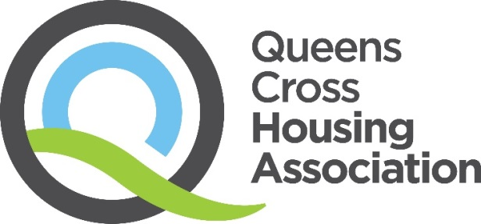
45 Firhill Road, Glasgow, G20 7BE
Telephone
0808 143 2002

Email
contactus@qcha.org.uk

Visit
www.qcha.org.uk

Need another version of this document?

We can provide this document in different formats. If you would like a copy of this document in another language, in large print, in Easy Read, on audio tape, on video in British Sign Language (BSL), on CD or in Braille, please ask us:
Telephone: 0808 143 2002
Email: contactus@qcha.org.uk
You can also download this document from our website at www.qcha.org.uk
