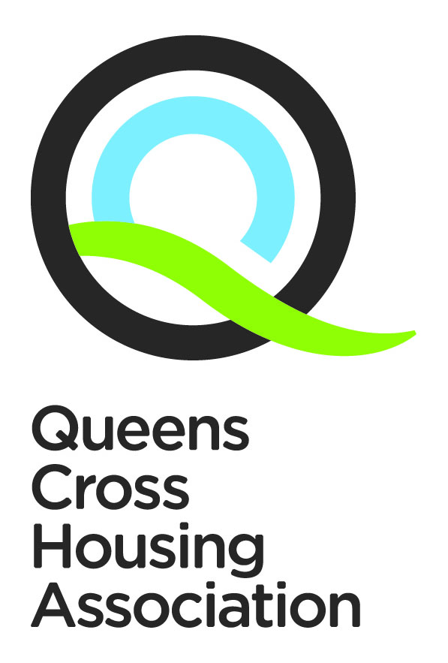
ITEM 6.2

Value for Money and Procurement Strategy
2026-2027

qcha.org.uk
0808 143 2002
contactus@qcha.org.uk


Our Vision, Values & Strategic Objectives
Our Vision, Values & Strategic Objectives

Our Vision

Excellent housing in vibrant communities

Our Values

Respect
We see the positive in everyone, especially our tenants. We treat everyone fairly, regardless of age, race, gender, sexuality or background. We ask for opinions even if we know we might not like what we hear. And we address people’s concerns in any way we realistically can.
Integrity
What we say in public is the same as what we say behind the scenes. If we say we’ll do something, we mean it. Our tenants can count on us to solve their problems and make sound decisions.
Aspiration
We want the best for all our current and future tenants. We’re not afraid to strive for things that won’t be easy – or try things that haven’t been done before. We seek out opportunities and welcome change. If it doesn’t turn out as planned, we learn and improve again. And then we try again.

Our Strategic Objectives for the period 2025-2029

- To keep rents affordable
- To invest in our tenants’ homes
- To provide safe and attractive neighbourhoods
- To involve our customers in our decision making
- To attract and develop our workforce

Contents

Section | Contents | Page
 | Foreword | 3
 | Introduction and background | 3
 | Where we are now | 4
 | Where we want to be…. Value for Money | 5
 | How we will get there…. Value for Money | 7
 | Monitoring and Evaluation…. Value for Money | 9
 | Where we want to be…. Procurement | 10
 | How we will get there…Procurement | 12
 | Monitoring and Evaluation…. Procurement | 13
 | Footnotes and References | 14

Value for Money and Procurement Strategy

1. Foreword
Queens Cross Housing Association’s Business Plan sets out our vision to provide affordable rents whilst continuing to invest in homes and our neighbourhood to deliver safe , clean and vibrant communites. This Value for Money (VfM) and Procurement Strategy support that vision by ensuring we achieve the best possible outcomes for tenants, customers and communities from the resources available to us.
The strategy provides a framework for how the Association will:
- deliver efficient and effective services.
- secure value through procurement and operational activity.
- maintain affordable services for tenants.
- strengthen sustainability and long-term asset value; and
- comply with the regulatory and legislative framework within which we operate.
Procurement and Value for Money are fundamental to the delivery of high-quality housing services. Through effective planning, strong governance and responsible procurement practices, the Association aims to maximise social, economic and environmental benefits for the communities we serve.
The current operating environment continues to present significant challenges, including inflationary pressures, supply chain disruption and increasing financial pressures on customers. Against this backdrop, achieving demonstrable Value for Money remains a key strategic priority.
This strategy outlines our approach, priorities and monitoring arrangements for Value for Money and Procurement over the next three years.

John McIntyre
Board Member

2. Introduction and Background
Queens Cross Housing Association was formed in 1976 and currently owns and manages more than 4,400 homes across the Dundasvale, Queens Cross, Woodside and Westercommon/Hamiltonhill areas of Glasgow.
The Association employs approximately 200 staff and operates within a group structure which includes:
- Queens Cross Factoring Ltd; and
- Queens Cross Workspace.
- Queens Cross Community Foundation
The Association has a long-standing commitment to delivering high-quality, affordable services while ensuring Value for Money across all areas of activity.
We recognise that Value for Money is not achieved simply through reducing cost, but through balancing:
- affordability.
- service quality.
- tenant outcomes.
- sustainability; and
- long-term asset value.
Our approach is informed by:
- benchmarking and performance analysis.
- customer and community feedback.
- robust financial management.
- effective procurement practices; and
- continuous improvement.
The Association operates within an increasingly challenging financial and procurement environment, shaped by inflation, supply chain pressures and wider economic uncertainty. These pressures reinforce the importance of strong procurement governance, effective financial planning and efficient service delivery.

3. Our Value for Money Approach

3.1 What Value for Money Means at Queens Cross
For Queens Cross, Value for Money means delivering the best possible outcomes for customers using resources effectively, efficiently and sustainably.
Our approach is based on the three recognised components of VfM:

Economy
Securing the best possible value from the resources used to deliver services, including staffing, procurement, maintenance and operational costs.

Efficiency
Using resources productively and delivering services in a streamlined and effective manner.

Effectiveness
Delivering positive outcomes for tenants and communities, including service quality, customer satisfaction and long-term sustainability.
The Association recognises that achieving Value for Money requires balancing cost, quality and customer outcomes rather than focusing solely on lowest cost.
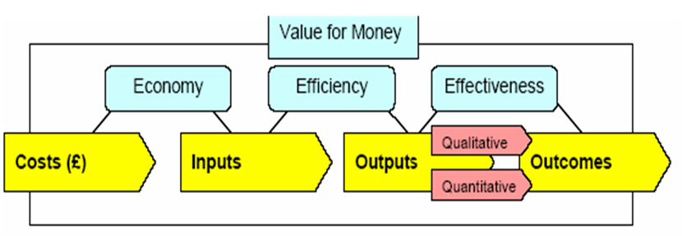

3.2 Strategic VfM Priorities
The Association’s strategic priorities for Value for Money are to:
- maximise the effective use of resources and income.
- deliver high-quality, customer-focused services.
- maintain affordable rents and sustainable tenancies.
- ensure homes remain financially and environmentally sustainable over the long term.
- strengthen procurement and contract management arrangements.
- improve operational efficiency through digital and data-driven approaches.
- benchmark performance and costs against peers.
- deliver social and community value through procurement and investment activity; and
- ensure robust governance, accountability and financial control.

4. Delivering Value for Money

4.1 Best Value Principles
Queens Cross will apply the principles of Best Value across all services and activities.
Our approach is based on the “4 Cs” model:
- Challenge how and why services are delivered.
- Compare performance and costs with peers and best practice.
- Consult with tenants, customers and stakeholders; and
- Compete effectively through procurement and market testing.

4.2 Key Actions

Performance and Benchmarking
The Association will:
- implement a VfM performance framework supported by KPI dashboards.
- benchmark costs, performance and customer outcomes through Housemark and sector partnerships.
- monitor indicators such as repair costs, arrears performance, void turnaround times and tenant satisfaction.
- strengthen service planning and performance reporting arrangements.
- use internal audit, service reviews and tenant scrutiny to support continuous improvement; and
- establish annual efficiency targets and monitor delivery against these.

Financial Management and Governance
The Association will:
- embed Value for Money considerations within all Board and management reporting.
- maintain clear budget accountability and financial monitoring arrangements.
- incorporate zero-based budgeting principles within financial planning where appropriate.
- ensure Value for Money is championed by the Board and Leadership Team.
- nominate the Director of Finance as VfM lead officer; and
- regularly review policies, structures and processes to support efficient service delivery.

Procurement and Contract Management
The Association will:
- ensure procurement activity achieves an appropriate balance between cost, quality and social value.
- maintain clear and transparent procurement procedures.
- regularly review contracts and procurement arrangements to ensure competitiveness and compliance.
- monitor supplier performance through formal frameworks covering cost, quality, compliance, customer satisfaction and social value.
- support opportunities for SMEs, social enterprises and local suppliers where appropriate; and
- use procurement to deliver wider community benefits.

Customer and Staff Engagement
The Association will:
- engage tenants and customers in service review and improvement activity.
- work with tenant groups and stakeholders to understand service priorities.
- support a culture of innovation and continuous improvement.
- encourage staff involvement in identifying efficiency opportunities; and
- communicate Value for Money achievements to tenants, staff and stakeholders.

Digital and Sustainable Service Delivery
The Association will:
- utilise digital systems and data-driven decision making to improve operational efficiency and customer experience.
- support modern and agile working practices where these improve service delivery.
- promote sustainable procurement and environmentally responsible practices.
- consider whole-life costs when evaluating investment and procurement decisions; and
- support long-term sustainability through effective asset management and energy efficiency improvements.

5. Monitoring and Reporting – Value for Money
Progress against this strategy will be monitored through:
- KPI dashboards and performance reporting.
- annual budget monitoring and financial reporting.
- benchmarking analysis.
- internal audit and service review activity.
- procurement and contract performance reporting.
- tenant feedback and satisfaction measures; and
- regular reporting to the Board and Audit Committee.
The Association will publish information on Value for Money performance within its annual performance reporting arrangements.
Where required, the Association will also comply with Scottish Government guidance relating to Value for Money assessments for development activity.

6. Procurement Strategy

6.1 Strategic Procurement Approach
The Association undertakes procurement activity across a wide range of works, goods and services, including responsive repairs, planned maintenance, development activity and corporate services.
As a contracting authority, Queens Cross complies with the Procurement Reform (Scotland) Act 2014 and associated procurement regulations.

Our procurement activity will be guided by the principles of:
- transparency.
- equal treatment and non-discrimination.
- proportionality.
- sustainability; and
- Value for Money.
The Association will select procurement routes appropriate to the scale, complexity and risk of each contract and will utilise external procurement frameworks where there is a clear operational or VfM benefit.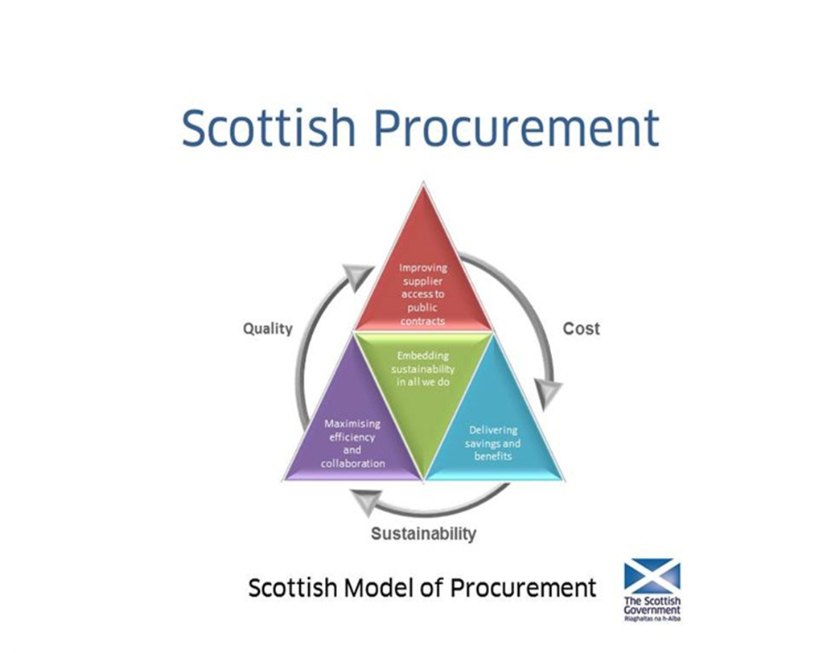

6.2 Procurement Priorities
The Association’s procurement priorities are to:
- achieve Value for Money through effective planning and procurement.
- maintain high-quality service delivery standards.
- strengthen contract and supplier management.
- support local economic and community benefits.
- improve efficiency through collaboration and framework opportunities.
- ensure procurement processes remain compliant, transparent and proportionate.
- support fair work practices, including Living Wage principles; and
- embed sustainability and environmental considerations within procurement activity.

6.3 Community Benefits and Sustainability
Queens Cross recognises that procurement activity can deliver wider social, economic and environmental benefits.
The Association will seek to deliver:
- local employment and apprenticeship opportunities.
- support for SMEs and social enterprises.
- environmental improvements and reduced carbon impact.
- fair work and ethical employment practices; and
- positive outcomes for local communities.
Supplier assessment and contract management arrangements will consider:
- financial and legal compliance.
- quality and service performance.
- equality and diversity.
- environmental performance; and
- social value commitments.

7. Procurement Delivery and Monitoring
The Association will monitor procurement performance through:
- quarterly departmental monitoring.
- contract performance reviews.
- procurement reporting to the Board and Executive.
- maintenance of a central Contract Register.
- annual procurement reporting.
- supplier performance monitoring; and
- periodic procurement improvement reviews.
An established Procurement Group will oversee implementation of the strategy and support continuous improvement.
The Association will publish an annual procurement report in line with legislative requirements, including:
- contracts awarded.
- procurement routes used.
- community benefit outcomes.
- compliance with procurement regulations; and
- planned regulated procurements.

8. Governance and Accountability
The following governance arrangements support delivery of this strategy:
Role | Responsibility
Board | Strategic oversight and approval
Audit Committee | Scrutiny of VfM performance and assurance
Leadership Team | Delivery and operational monitoring
Director of Finance | VfM leadership and financial oversight
Procurement Group | Procurement governance and improvement
Managers | Budget management and service performance

9. Scope
This strategy applies to all procurement and Value for Money activity undertaken by Queens Cross Housing Association and its subsidiary companies.

10. References
- Procurement Reform (Scotland) Act 2014
- Housemark Scotland – Value for Money Guidance
- Scottish Social Housing Charter
- Public Contracts (Scotland) Regulations 2015

Procurement Delivery plan
Strategic Aim | How we will Achieve This | Outcome
Delivering quality of service, savings and benefits | By planning our procurements carefully, selecting the best route to achieve the desired outcome  By balancing quality and price in the outcome, including consideration of whole life cost and added value offers  By understanding and reflecting our customers’ needs in service requirements  By applying our Community Benefits approach as a standard requirement in all procurements | Budget targets met  Value for money in short and long term - improved standards in service delivery and savings achieved  Suppliers deliver for customers (Customer First) and reflect the Association’s values  Community Benefits delivered in proportion to contract value
Maximising efficiency and collaboration | By monitoring procurement processes and outcomes, and identifying opportunities for innovation and areas for improvement  By drawing upon external Frameworks when there is a clear VfM benefit  By procuring goods and services as a Group (inc. the QC subsidiaries) or with other RSLs where our requirements align | Continuous improvement in procurement processes  Continue to meet legal and regulatory requirements with streamlined resources  Establish group approach and improve quality and efficiency  Joint procurement opportunities
Improving supplier access to public contracts | By promoting opportunities across a range of media and using the Public Contracts Scotland portal for regulated procurements  By standardising and simplifying our procurement processes, including use of the ESPD for pre-qualification  By providing opportunities through the procurement process for SMEs and Social Enterprises  By collecting feedback from suppliers on our procurement processes | Increased awareness amongst suppliers and greater competition  SMEs and Social Enterprises can compete for contracts  Measurable benefits to the community  Continuous improvement in procurement processes
Embedding sustainability in all we do | By adopting a consistent (fair and transparent) procurement approach, and actively managing/monitoring supplier performance  By retaining “Living Wage” accreditation  By designing procurement routes to promote sustainability by i) using environmental metrics to compare potential suppliers and ii) engaging suppliers who can evidence ethical and sustainable practices e.g. positive Social / Environmental impacts, Equality and Diversity etc.  By publishing an annual report on procurement activities which reviews the outcomes against our targets | Positive long-term relationships with suppliers are developed  Our suppliers offer the real Living Wage to their employees  Wider economic, social and environmental benefits are achieved through procurement activity and evidence is gathered on a reduction in our Carbon Footprint  Sustainability goals remain central and targets are regularly refreshed

Contact Us
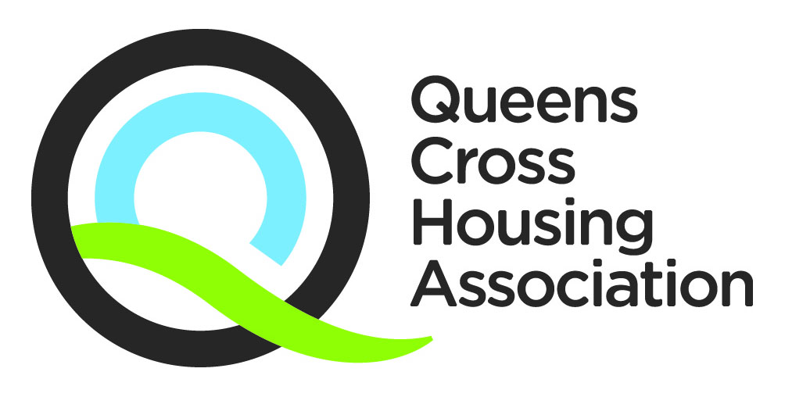

Telephone: 0808 143 2002
Email: contactus@qcha.org.uk
You can also download this document from our website at www.qcha.org.uk
Need another version of this document?

We can provide his document in different formats. If you would like a copy of this document in another language, in large print, in Easy Read, on audio tape, on video in British Sign Language (BSL), on CD or in Braille, please ask us.

